Day 13:

Task 1:

// Online C compiler to run C program online

#include <stdio.h>

int main() {

// Write C code here

int age;

int *ptr;

age = 10;

ptr = &age;

printf("value of age is %d", age);

printf("\nptr is ponting to %d", *ptr);

printf("\naddress of age %d", &age);

printf("\nvalue of ptr %d", ptr);

printf("\nvalue of *ptr %d", &ptr);

return 0;

}

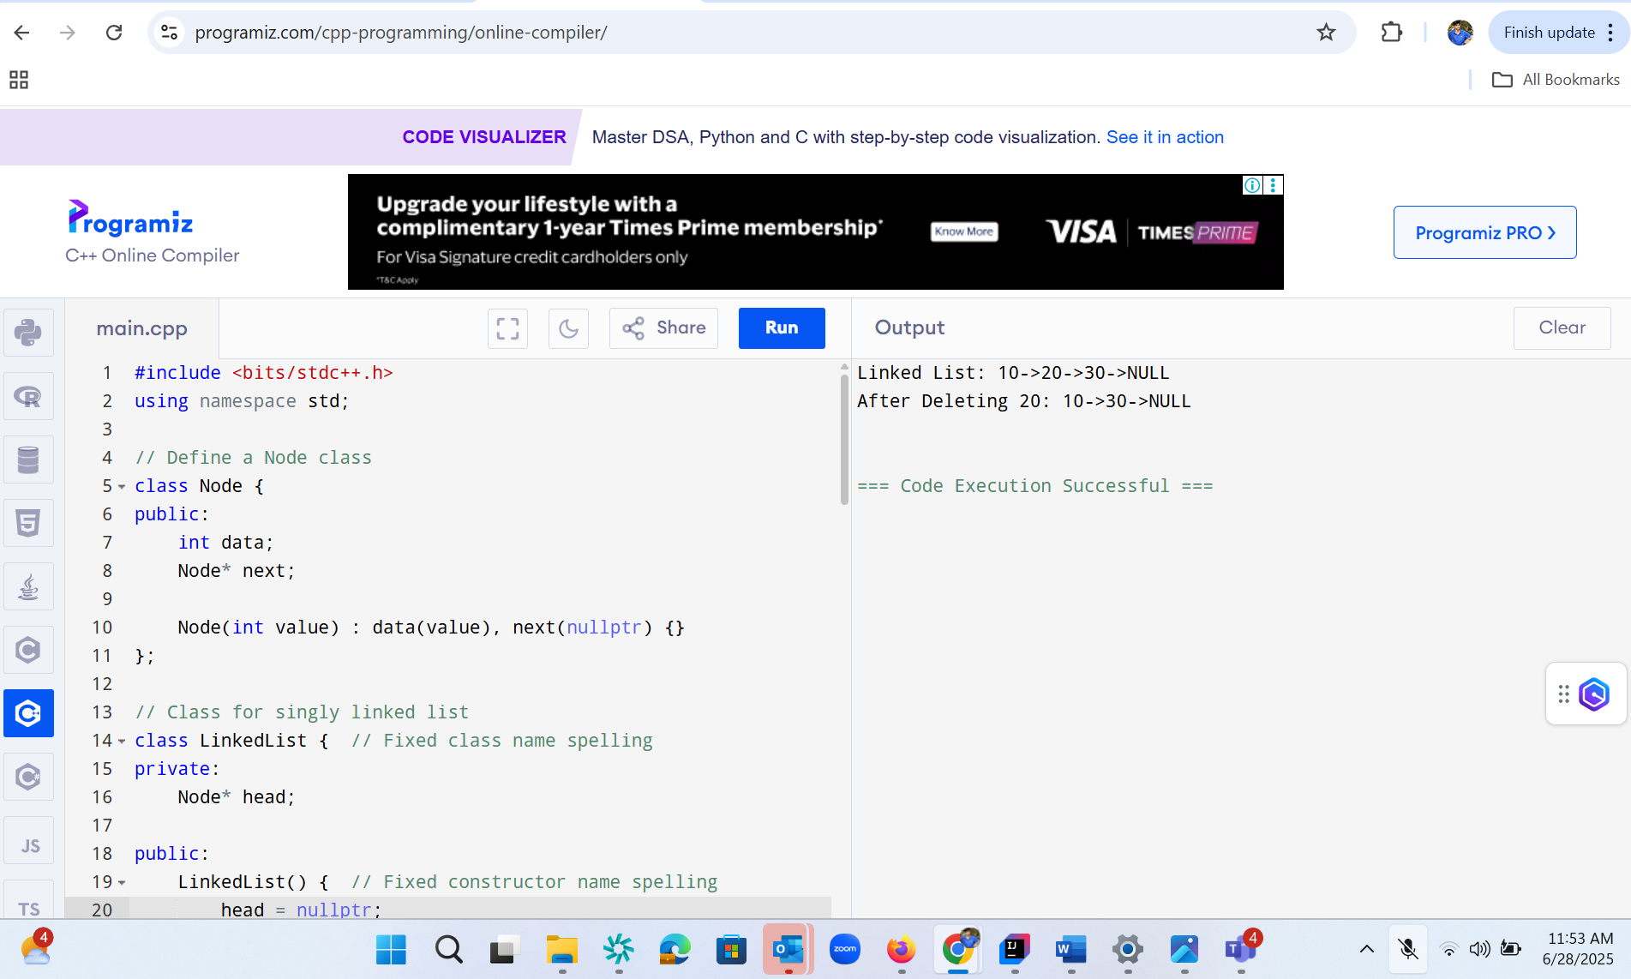

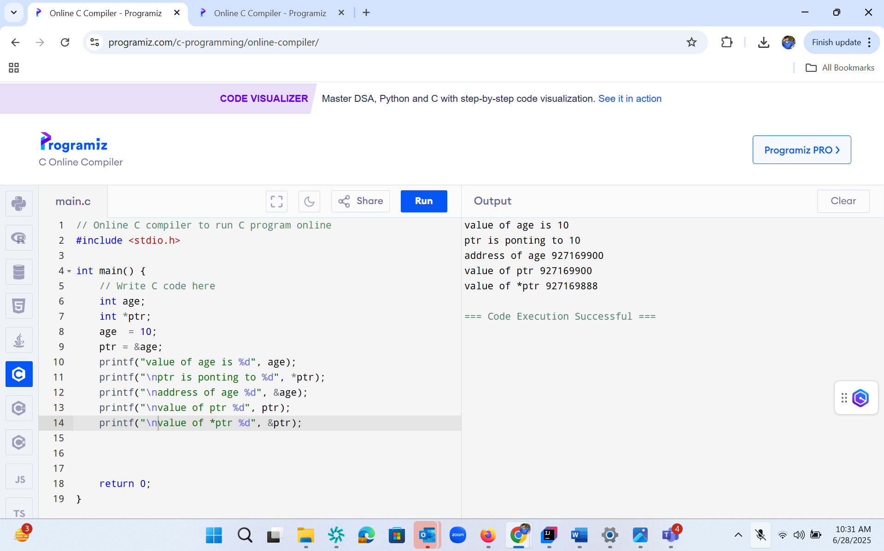

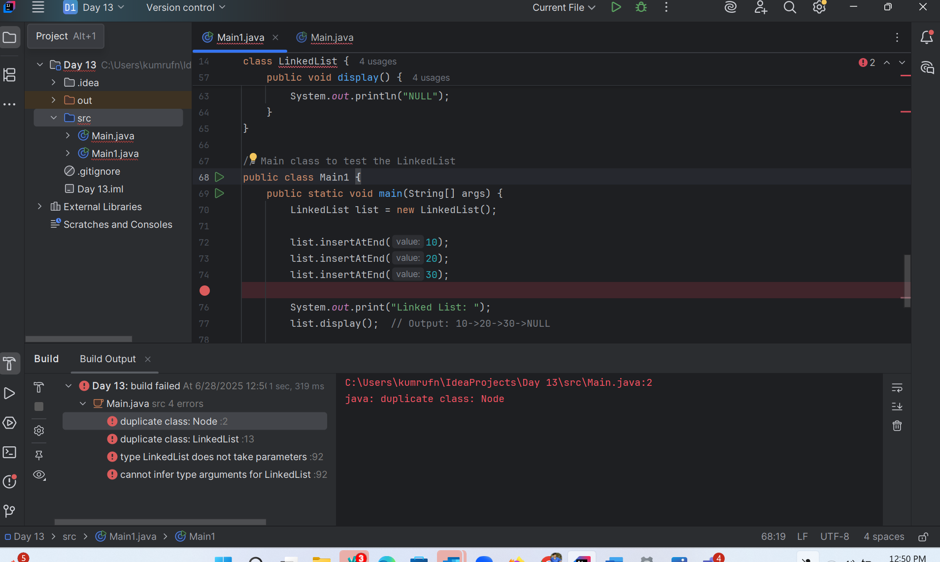

Task 4:

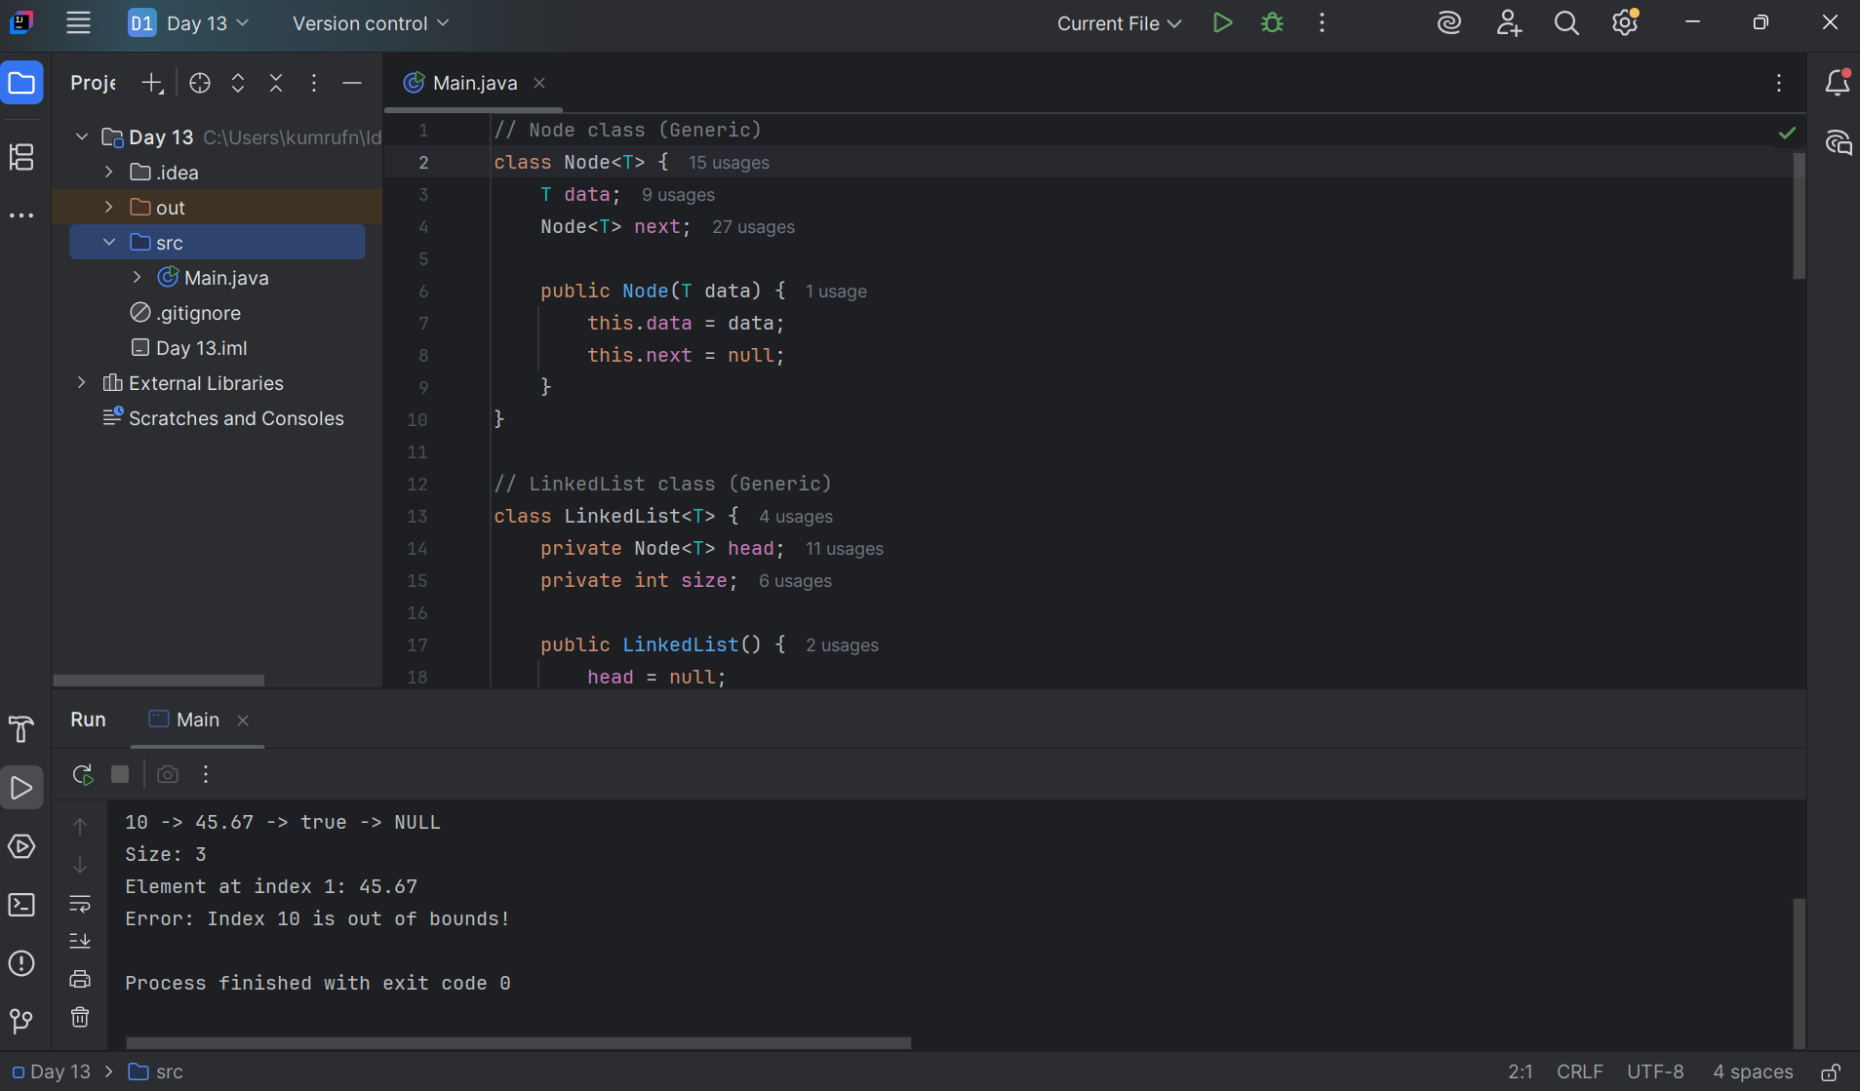

Task 5 :

List down all the methods of Linked list?

A linked list data structure provides several core methods for managing its elements. These include methods for adding, removing, accessing, and traversing elements. Here's a breakdown of common linked list methods:

Basic Operations:

* add(element) / addLast(element): Appends the specified element to the end of the list.
* addFirst(element): Adds the specified element to the beginning of the list.
* remove(element) / removeFirstOccurrence(element): Removes the first occurrence of the specified element from the list.
* removeFirst(): Removes and returns the first element of the list.
* removeLast(): Removes and returns the last element of the list.
* get(index): Returns the element at the specified position in the list.
* set(index, element): Replaces the element at the specified position in the list with the specified element.
* indexOf(element): Returns the index of the first occurrence of the specified element in the list, or -1 if this list does not contain the element.
* lastIndexOf(element): Returns the index of the last occurrence of the specified element in the list, or -1 if this list does not contain the element.
* contains(element): Returns true if the list contains the specified element.
* size(): Returns the number of elements in the list.
* isEmpty(): Returns true if the list contains no elements.
* clear(): Removes all of the elements from the list.

Traversal and Iteration:

* iterator(): Returns an iterator over the elements in the list (in proper sequence).
* listIterator(): Returns a list iterator over the elements in the list (in proper sequence).
* listIterator(int index): Returns a list iterator over the elements in the list (in proper sequence), starting at the specified position in the list.

Advanced Operations (often available in specific implementations):

* add(index, element): Inserts the specified element at the specified position in the list.
* addAll(Collection<? extends E> c): Appends all of the elements in the specified collection to the end of the list.
* addAll(int index, Collection<? extends E> c): Inserts all of the elements in the specified collection into the list, starting at the specified position.
* remove(int index): Removes the element at the specified position in the list.
* peek(): Retrieves, but does not remove, the first element of the list (head).
* poll(): Retrieves and removes the first element of the list (head).
* offer(E e): Adds the specified element as the tail (last element) of the list.
* push(E e): Pushes an element onto the stack represented by this list.
* pop(): Pops an element from the stack represented by this list.

These methods provide a comprehensive set of functionalities for working with linked lists, allowing for efficient insertion, deletion, and access to elements within the list. The specific methods available may vary slightly depending on the programming language and the implementation of the linked list (e.g., singly linked, doubly linked, circular).

Task 6 :

get first and get last elements and display all elements in the linked list

task 7:

 Remove first and remove last element and display all elements in the linked list Task 7?

Task 8: in the list update the 1st element to a new value Hint: use set(1, "new value");

import java.util.LinkedList;

import java.util.ListIterator;

public class LinkedListDemo {

public static void main(String[] args) {

// 1. Create a LinkedList of Strings

LinkedList<String> list = new LinkedList<>();

// 2. Add elements

list.add("Apple");

list.add("Banana");

list.add("Cherry");

System.out.println("After adding: " + list);

// 3. Add element at specific position

list.add(1, "Blueberry");

System.out.println("After inserting at index 1: " + list);

// 4. Remove elements

list.remove("Banana");

System.out.println("After removing 'Banana': " + list);

String removed = list.removeFirst();

System.out.println("Removed first element (" + removed + "): " + list);

// 5. Access elements

String first = list.getFirst();

String last = list.getLast();

System.out.println("First element: " + first);

System.out.println("Last element: " + last);

// 6. Iterate using for-each

System.out.print("Iterate (for-each): ");

for (String fruit : list) {

System.out.print(fruit + " ");

}

System.out.println();

// 7. Iterate using ListIterator

System.out.print("Iterate (ListIterator): ");

ListIterator<String> it = list.listIterator();

while (it.hasNext()) {

System.out.print(it.next() + " ");

}

System.out.println();

// 8. Check if contains

System.out.println("Contains 'Cherry'? " + list.contains("Cherry"));

// 9. Size and clear

System.out.println("Size: " + list.size());

list.clear();

System.out.println("After clear, isEmpty? " + list.isEmpty());

}

}

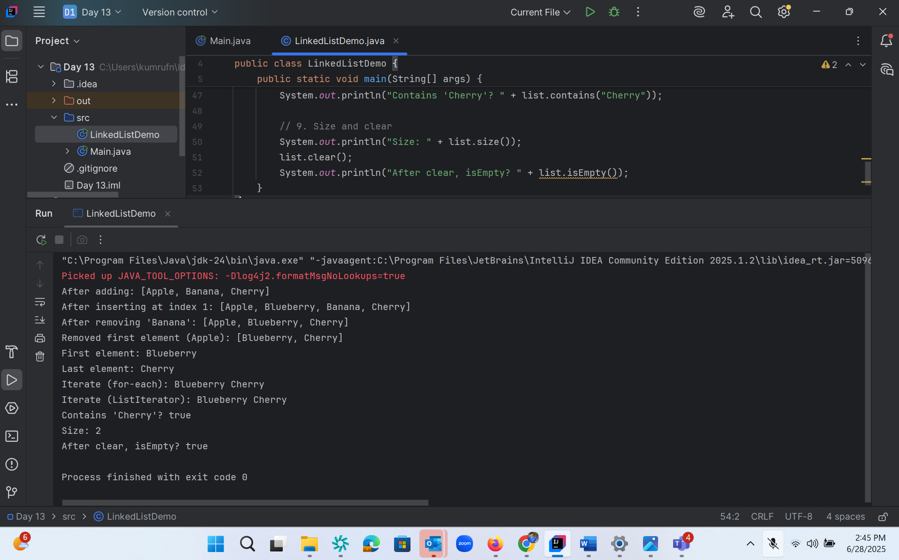

Or :

import java.util.LinkedList;  
  
public class task06 {  
 public static void main(String[] args) {  
 // Create LinkedList of strings  
 LinkedList<String> fruits = new LinkedList<>();  
  
 // Add elements to the list  
 fruits.add("Apple");  
 fruits.add("Banana");  
 fruits.add("Mango");  
 fruits.add("Orange");  
  
 // Display the list  
 System.*out*.println("Fruits List: " + fruits);  
  
 // Add at first and last  
 fruits.addFirst("Pineapple");  
 fruits.addLast("Grapes");  
  
 System.*out*.println("After adding first and last: " + fruits);  
  
  
 }  
}

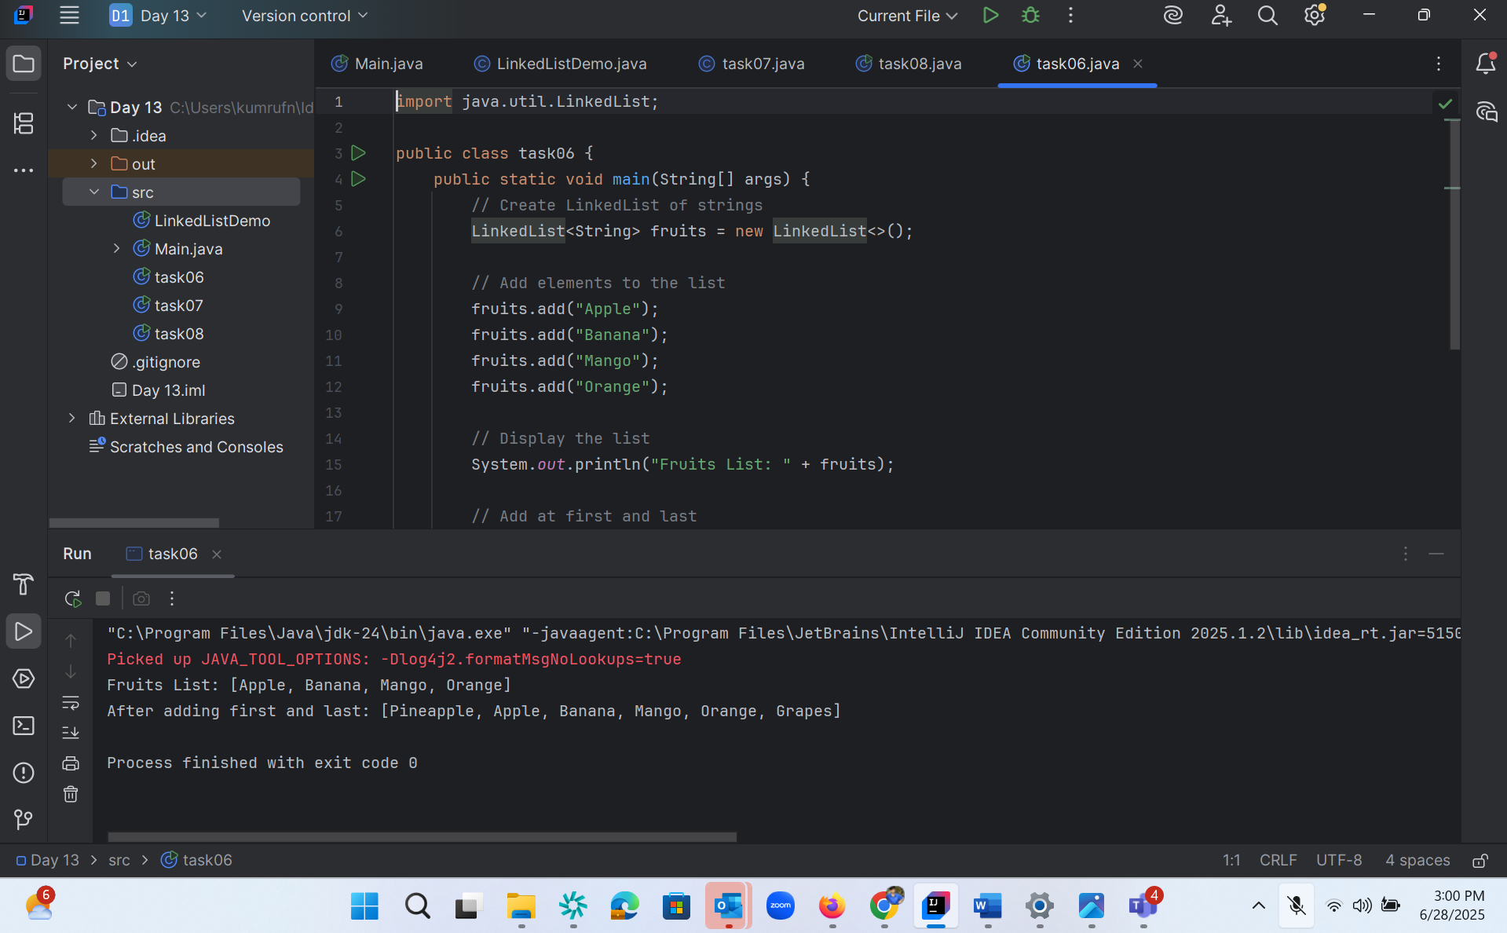

Task 7:

import java.util.LinkedList;  
  
public class task07 {  
 public static void main(String[] args) {  
 // Create LinkedList of strings  
 LinkedList<String> fruits = new LinkedList<>();  
  
 // Add elements to the list  
 fruits.add("Apple");  
 fruits.add("Banana");  
 fruits.add("Mango");  
 fruits.add("Orange");  
  
 // Display the list  
 System.*out*.println("Fruits List: " + fruits);  
  
 // Add at first and last  
 fruits.addFirst("Pineapple");  
 fruits.addLast("Grapes");  
  
 System.*out*.println("After adding first and last: " + fruits);  
  
 // Removing the first element  
 fruits.removeFirst();  
  
 // Removing the last element  
 fruits.removeLast();  
  
 // Displaying the updated LinkedList  
 System.*out*.println("After removing first and last: " + fruits);  
 }  
}

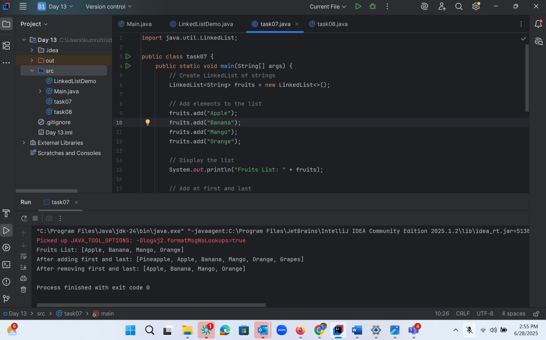

Task 8:

import java.util.LinkedList;  
  
public class task08 {  
 public static void main(String[] args) {  
 // Create LinkedList of strings  
 LinkedList<String> fruits = new LinkedList<>();  
  
 // Add elements to the list  
 fruits.add("Apple");  
 fruits.add("Banana");  
 fruits.add("Mango");  
 fruits.add("Orange");  
  
 // Display the list  
 System.*out*.println("Fruits List: " + fruits);  
  
 // Add at first and last  
 fruits.addFirst("Pineapple");  
 fruits.addLast("Grapes");  
  
 System.*out*.println("After adding first and last: " + fruits);  
  
 // Removing the first element  
 fruits.removeFirst();  
  
 // Removing the last element  
 fruits.removeLast();  
  
 // Displaying the updated LinkedList  
 System.*out*.println("After removing first and last: " + fruits);  
 // Updating the first element  
 fruits.set(1, "Pineapple");  
  
 // Displaying the updated list  
 System.*out*.println("Updated list: " + fruits);  
 }  
}

or

import java.util.LinkedList;  
  
public class task08 {  
 public static void main(String[] args) {  
 // Initialize the list  
 LinkedList<String> fruits = new LinkedList<>();  
 fruits.add("Apple");  
 fruits.add("Banana");  
 fruits.add("Cherry");  
 System.*out*.println("Before: " + fruits);  
  
 // Update the 1st element (index 0)  
 String old = fruits.set(0, "Apricot");  
 System.*out*.println("Replaced \"" + old + "\" with \"Apricot\"");  
  
 // Display the updated list  
 System.*out*.println("After: " + fruits);  
 }  
}

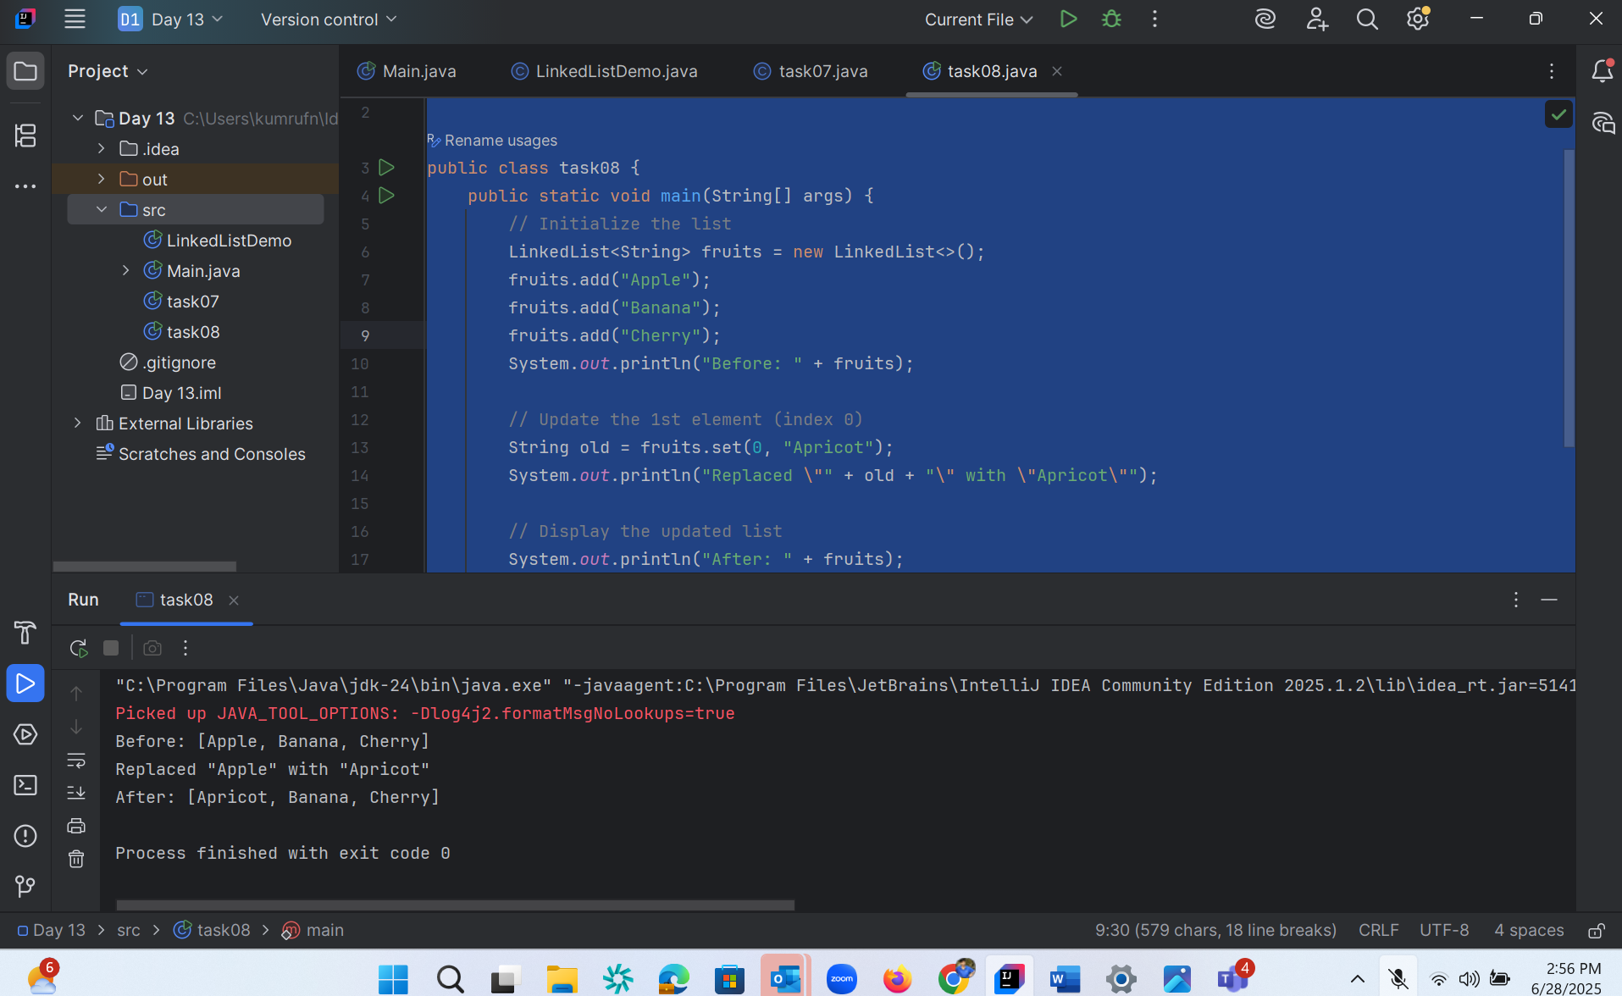

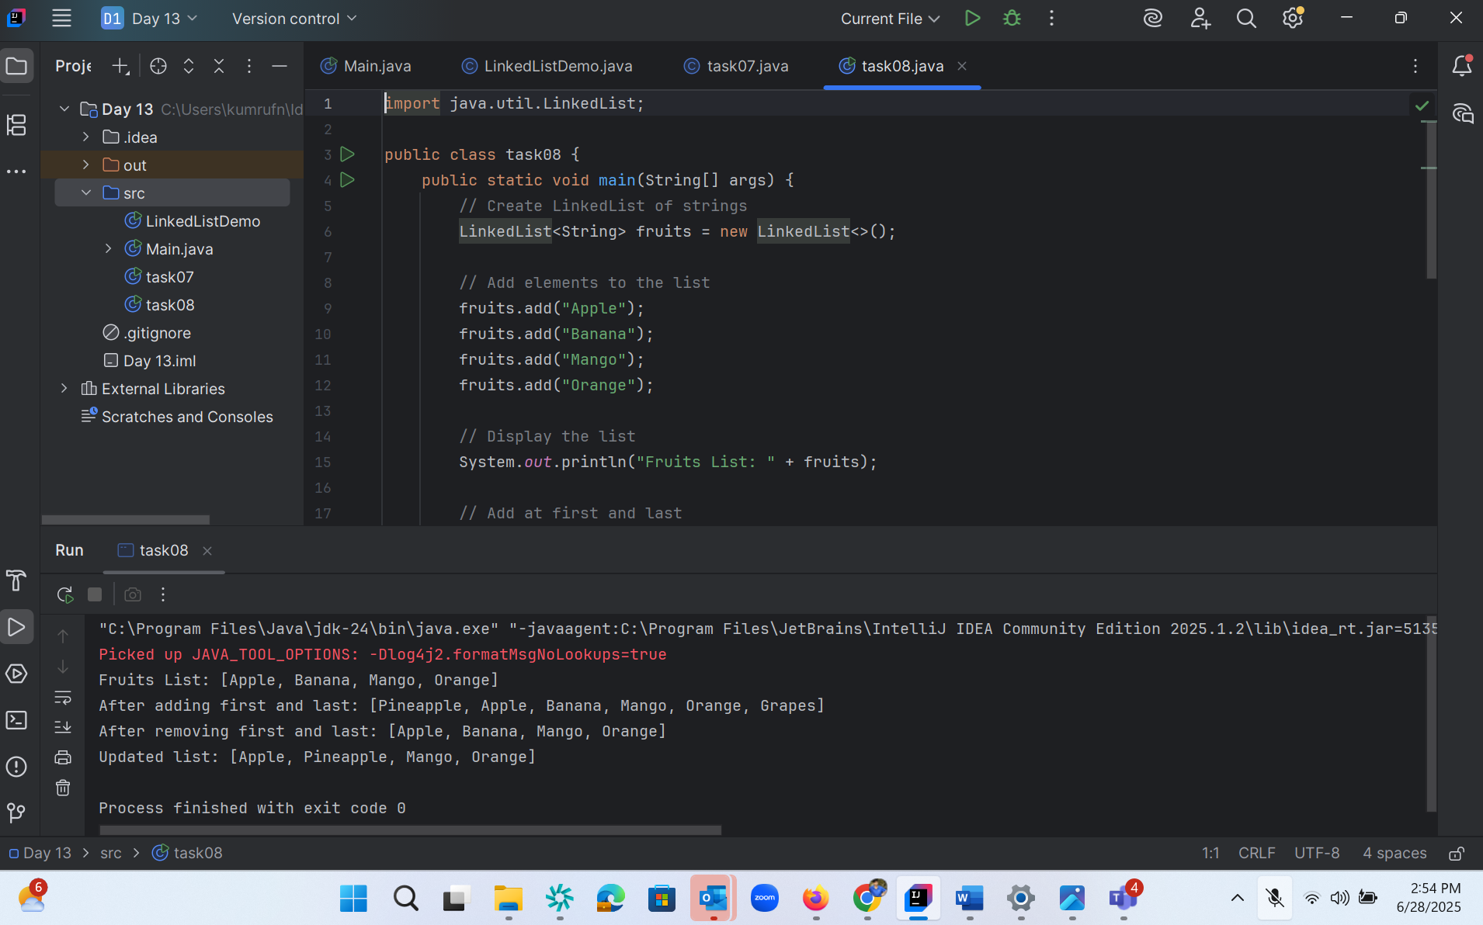

Task 9:

Display the list twice 1..... with get method in for loop and 2 ... for each loop

import java.util.LinkedList;  
  
public class task09 {  
 public static void main(String[] args) {  
 LinkedList<String> fruits = new LinkedList<>();  
 fruits.add("Apple");  
 fruits.add("Banana");  
 fruits.add("Cherry");  
 fruits.add("Date");  
  
 // 1. Traditional for loop with get()  
 System.*out*.println("Using get() in for loop:");  
 for (int i = 0; i < fruits.size(); i++) {  
 System.*out*.println("Index " + i + ": " + fruits.get(i));  
 }  
  
 System.*out*.println(); // blank line  
  
 // 2. Enhanced for-each loop  
 System.*out*.println("Using enhanced for-each loop:");  
 for (String fruit : fruits) {  
 System.*out*.println(fruit);  
 }  
 }  
}

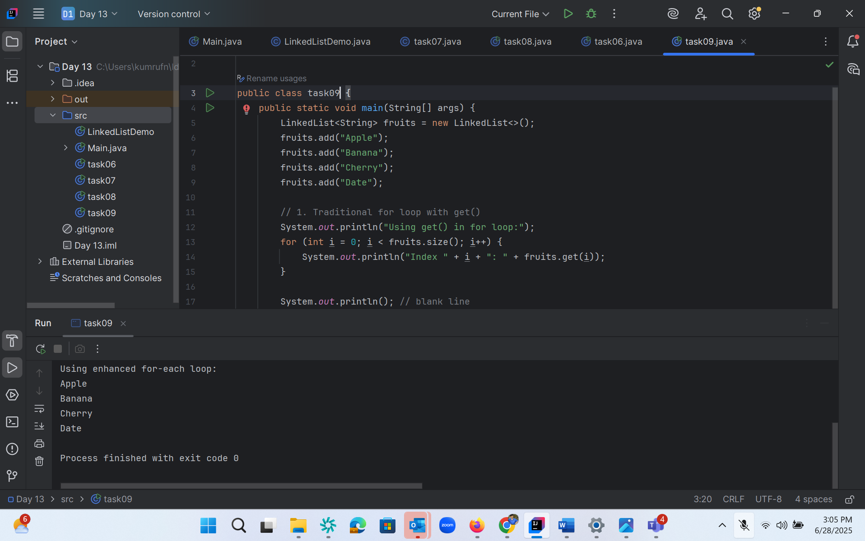

Task 10 :

Task 10: display the elements of the linked list with out loops

import java.util.LinkedList;  
  
public class task10 {  
 public static void main(String[] args) {  
 // Create and populate the LinkedList  
 LinkedList<String> fruits = new LinkedList<>();  
 fruits.add("Apple");  
 fruits.add("Banana");  
 fruits.add("Mango");  
 fruits.add("Orange");  
  
 // Display the LinkedList without using loops  
 System.*out*.println("LinkedList elements: " + fruits);  
 }  
}

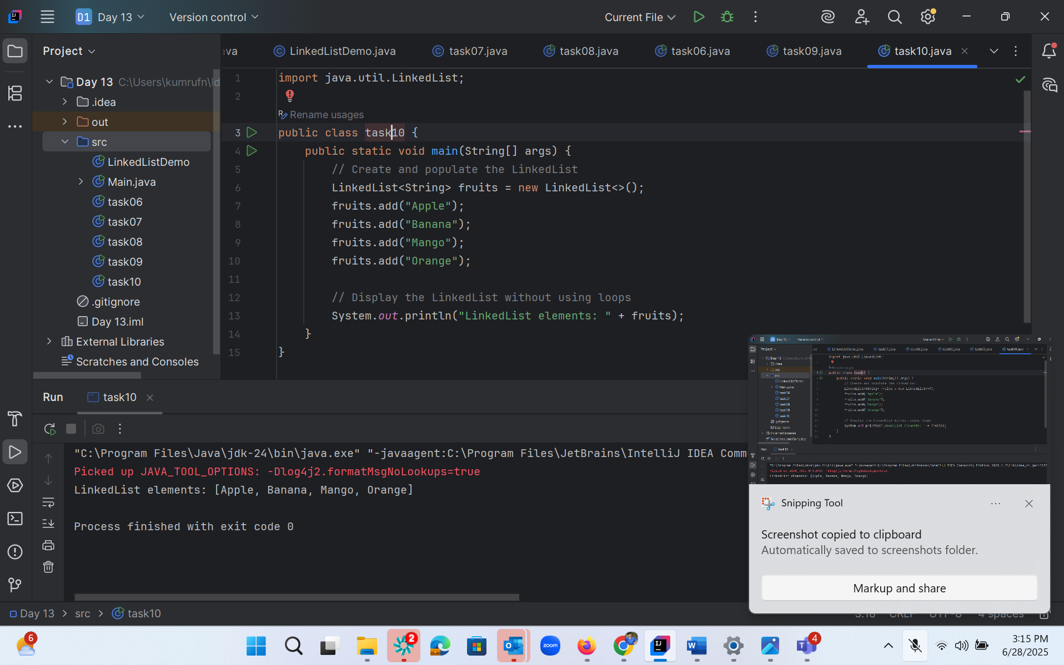

task 11:

Convert the linked list to an array and display Hint : Object[] a = llobj.toArray(); ?

import java.util.LinkedList;  
import java.util.Arrays;  
  
public class task11 {  
 public static void main(String[] args) {  
 // Create and populate the LinkedList  
 LinkedList<String> fruits = new LinkedList<>();  
 fruits.add("Apple");  
 fruits.add("Banana");  
 fruits.add("Mango");  
 fruits.add("Orange");  
  
 // Convert LinkedList to array  
 Object[] fruitArray = fruits.toArray();  
 System.*out*.println(Arrays.*toString*(fruitArray));  
  
 // Display the array elements  
 System.*out*.println("Elements in array form:");  
 for (Object fruit : fruitArray) {  
 System.*out*.println(fruit);  
 }  
 }  
}

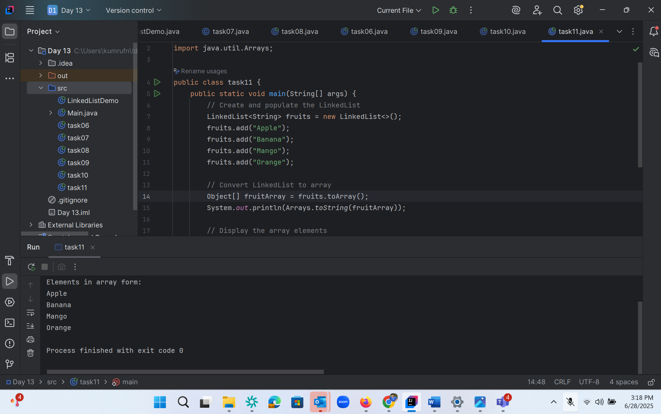

Task 12:

Task 12: clone the linked list to check if its getting cloned?

 import java.util.LinkedList;  
  
public class task12 {  
 public static void main(String[] args) {  
 // Create and populate the original LinkedList  
 LinkedList<String> fruits = new LinkedList<>();  
 fruits.add("Apple");  
 fruits.add("Banana");  
 fruits.add("Mango");  
  
 // Clone the LinkedList  
 LinkedList<String> clonedList = (LinkedList<String>) fruits.clone();  
  
 // Display original and cloned lists  
 System.*out*.println("Original LinkedList: " + fruits);  
 System.*out*.println("Cloned LinkedList: " + clonedList);  
 System.*out*.println("Same object? " + (fruits == clonedList));  
 }  
}

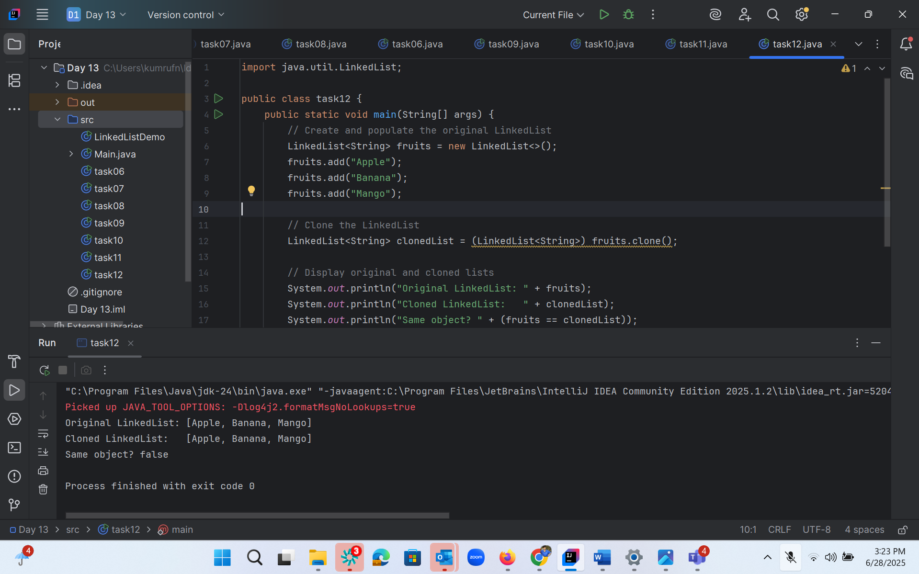

Task 13:

import java.util.LinkedList;  
  
public class task013 {  
 public static void main(String[] args) {  
 // Create and populate a LinkedList  
 LinkedList<String> fruits = new LinkedList<>();  
 fruits.add("Banana");  
 fruits.add("Mango");  
 fruits.add("Orange");  
  
 System.*out*.println("Original List: " +fruits);  
 // Use push() to add an element at the front (like stack)  
 fruits.push("Apple"); // Same as addFirst()  
  
 System.*out*.println("After push: " + fruits); // [Apple, Banana, Mango, Orange]  
  
 // Use pop() to remove the first element (like stack)  
 String popped = fruits.pop(); // Removes "Apple"  
  
 System.*out*.println("Popped element: " + popped);  
 System.*out*.println("After pop: " + fruits); // [Banana, Mango, Orange]  
 }  
}

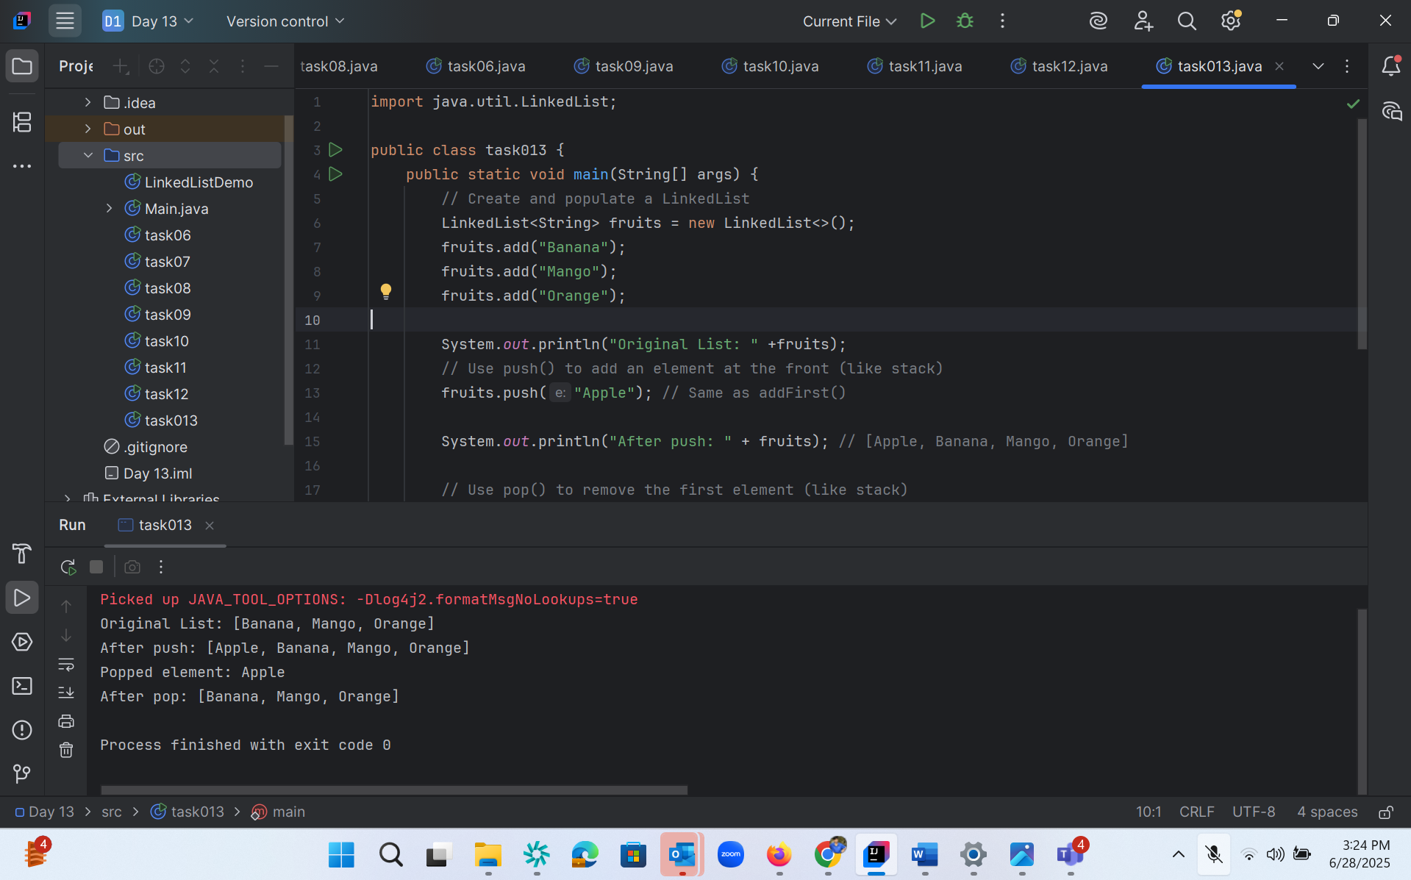

Task 14:

Task 14:

Splititerator

import java.util.*;

public class Task0014_DS_Linkedlist_SplitIterator {

    public static void main(String[] args) {

        LinkedList<String> lobj = new LinkedList<>();

        lobj.add("Prasunamba");

        lobj.add("Meher");

        lobj.add(".MK");

        Spliterator<String> sitobj = lobj.spliterator();

//forEachRemaining is a method of Spliterator

        System.out.println("Splitting the list:");

        sitobj.forEachRemaining(System.out::println);

    }

}

Or :

import java.util.LinkedList;  
import java.util.Spliterator;  
  
public class task014{  
 public static void main(String[] args) {  
 // Create and populate LinkedList  
 LinkedList<String> fruits = new LinkedList<>();  
 fruits.add("Banana");  
 fruits.add("Mango");  
 fruits.add("Orange");  
  
 // Get a Spliterator for the LinkedList  
 Spliterator<String> sitobj = fruits.spliterator();  
  
 // Print elements using forEachRemaining method  
 System.*out*.println("Splitting the list:");  
 sitobj.forEachRemaining(System.*out*::println);  
 }  
}

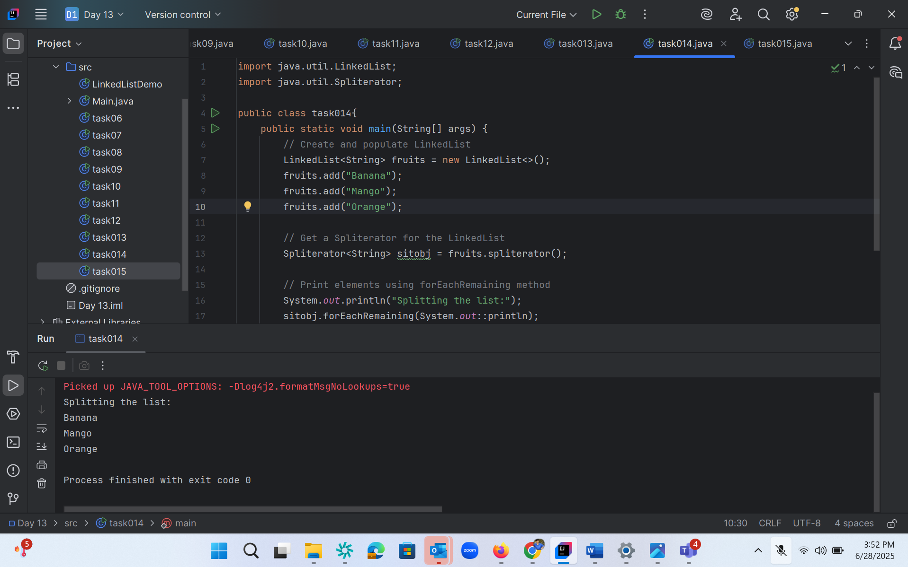

Task 15 :

Try advanced in spliterator ?

Prasuna code :

tryAdvance()

import java.util.LinkedList;

import java.util.Spliterator;

public class Task0015_DS_Linkedlist_SplitItr2Lists {

public static void main(String[] args) {

    LinkedList<String> llobj = new LinkedList<String>();

    llobj.add("Prasunamba");

    llobj.add("Meher");

    llobj.add(".MK");

    llobj.add("MP");

    Spliterator<String> itobj1 = llobj.spliterator();

    Spliterator<String> itobj2 = itobj1.trySplit();

    System.out.println("spliterator 1");

    while( itobj1.tryAdvance( (n) -> { System.out.println(n); } ) );

    System.out.println("spliterator 2");

    while( itobj2.tryAdvance( (n) -> { System.out.println(n); } ) );

  }

}

Or

Own code:

import java.util.LinkedList;  
import java.util.Spliterator;  
  
public class task015 {  
 public static void main(String[] args) {  
 LinkedList<String> llobj = new LinkedList<>();  
 llobj.add("Sarath");  
 llobj.add("Kumar");  
 llobj.add("BE");  
 llobj.add("ME");  
  
  
 Spliterator<String> itobj1 = llobj.spliterator();  
 Spliterator<String> itobj2 = itobj1.trySplit();  
  
 System.*out*.println("Spliterator 1:");  
 while (itobj1 != null && itobj1.tryAdvance(n -> System.*out*.println(n)));  
  
 System.*out*.println("Spliterator 2:");  
 while (itobj2 != null && itobj2.tryAdvance(n -> System.*out*.println(n)));  
 }  
}

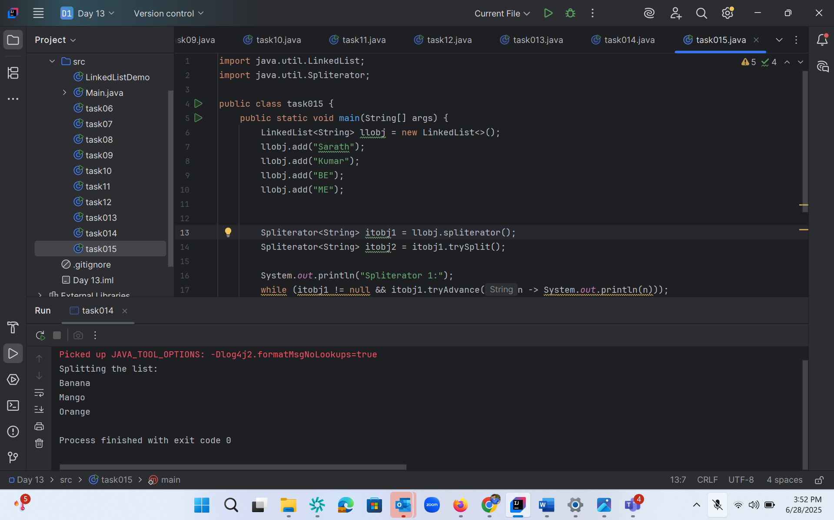

Task 16 :

class Node2 {  
 String data;  
 Node2 prev;  
 Node2 next;  
  
 Node2(String data) {  
 this.data = data;  
 this.prev = null;  
 this.next = null;  
 }  
}  
  
class DoublyLinkedList {  
 Node2 head;  
  
 // Add to end  
 public void add(String data) {  
 Node2 newNode = new Node2(data);  
 if (head == null) {  
 head = newNode;  
 return;  
 }  
  
 Node2 temp = head;  
 while (temp.next != null) {  
 temp = temp.next;  
 }  
  
 temp.next = newNode;  
 newNode.prev = temp;  
 }  
  
 // Display forward  
 public void displayForward() {  
 Node2 temp = head;  
 System.*out*.print("Forward: ");  
 while (temp != null) {  
 System.*out*.print(temp.data + " ");  
 temp = temp.next;  
 }  
 System.*out*.println();  
 }  
  
 // Display backward  
 public void displayBackward() {  
 Node2 temp = head;  
 if (temp == null) return;  
  
 // Move to the last node  
 while (temp.next != null) {  
 temp = temp.next;  
 }  
  
 // Print in reverse  
 System.*out*.print("Backward: ");  
 while (temp != null) {  
 System.*out*.print(temp.data + " ");  
 temp = temp.prev;  
 }  
 System.*out*.println();  
 }  
}  
  
public class task016 {  
 public static void main(String[] args) {  
 DoublyLinkedList dll = new DoublyLinkedList();  
  
 dll.add("Apple");  
 dll.add("Banana");  
 dll.add("Mango");  
  
 dll.displayForward(); // Output: Forward: Apple Banana Mango  
 dll.displayBackward(); // Output: Backward: Mango Banana Apple  
 }  
}

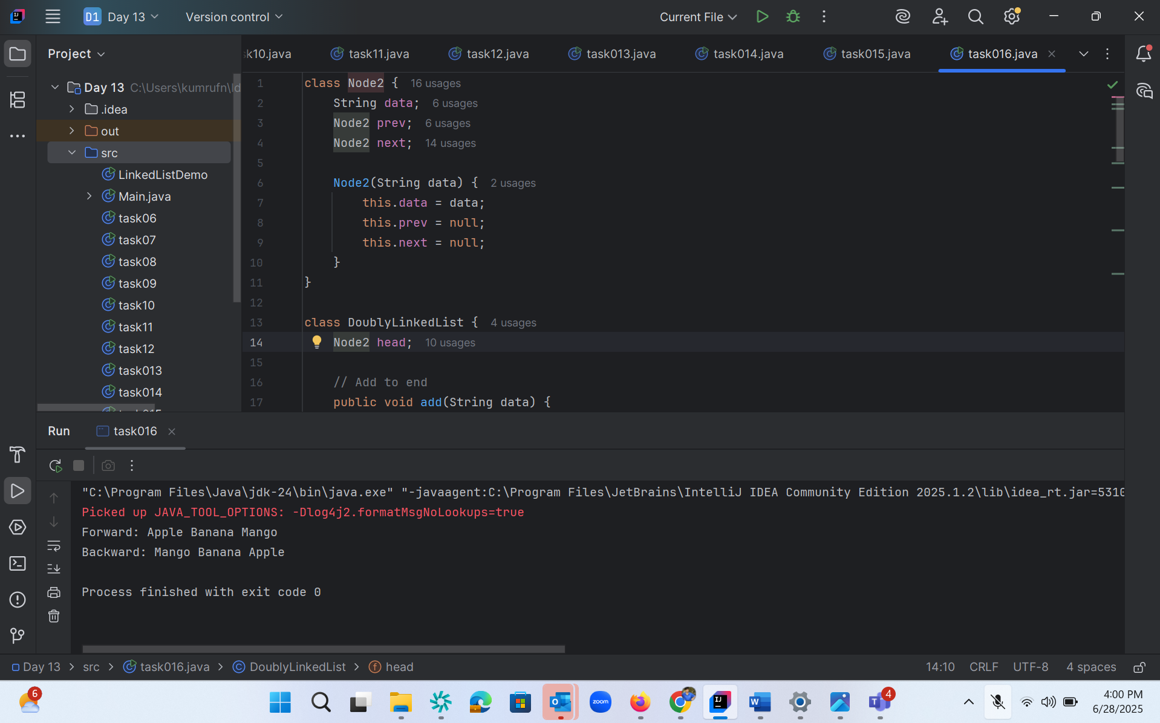

Task 17 :

Task 17:

Create a Hash MAp of capacity 10.

Hint:

HashMap<String, Integer> hm2 = new HashMap<String, Integer>(10);

import java.util.HashMap;  
  
public class task017 {  
 public static void main(String[] args) {  
 // Create HashMap with initial capacity of 10  
 HashMap<String, Integer> hm = new HashMap<String, Integer>(10);  
  
 // Adding elements  
 hm.put("A", 1);  
 hm.put("B", 2);  
 hm.put("C", 3);  
 hm.put("D", 4);  
 hm.put("E", 5);  
  
 // Display the HashMap  
 System.*out*.println("HashMap: " + hm);  
  
 // Basic operations  
 // 1. Get value  
 System.*out*.println("Value for key 'A': " + hm.get("A"));  
  
 // 2. Check if key exists  
 System.*out*.println("Contains key 'B'? " + hm.containsKey("B"));  
  
 // 3. Check if value exists  
 System.*out*.println("Contains value 3? " + hm.containsValue(3));  
  
 // 4. Remove an element  
 hm.remove("C");  
 System.*out*.println("After removing 'C': " + hm);  
  
 // 5. Size of HashMap  
 System.*out*.println("Size: " + hm.size());  
  
 // 6. Check if empty  
 System.*out*.println("Is empty? " + hm.isEmpty());  
  
 // 7. Clear the HashMap  
 hm.clear();  
 System.*out*.println("After clearing: " + hm);  
  
 // Adding more elements to demonstrate capacity  
 for(int i = 1; i <= 10; i++) {  
 hm.put("Key" + i, i);  
 }  
 System.*out*.println("After adding 10 elements: " + hm);  
 }  
}

or

import java.util.HashMap;  
  
public class task017 {  
 public static void main(String[] args) {  
 // Create a HashMap with initial capacity of 10  
 HashMap<String, Integer> hm2 = new HashMap<String, Integer>(10);  
  
 // Add some key-value pairs  
 hm2.put("Apple", 3);  
 hm2.put("Banana", 5);  
 hm2.put("Mango", 7);  
  
 // Display the HashMap  
 System.*out*.println("HashMap contents: " + hm2);  
 }  
}

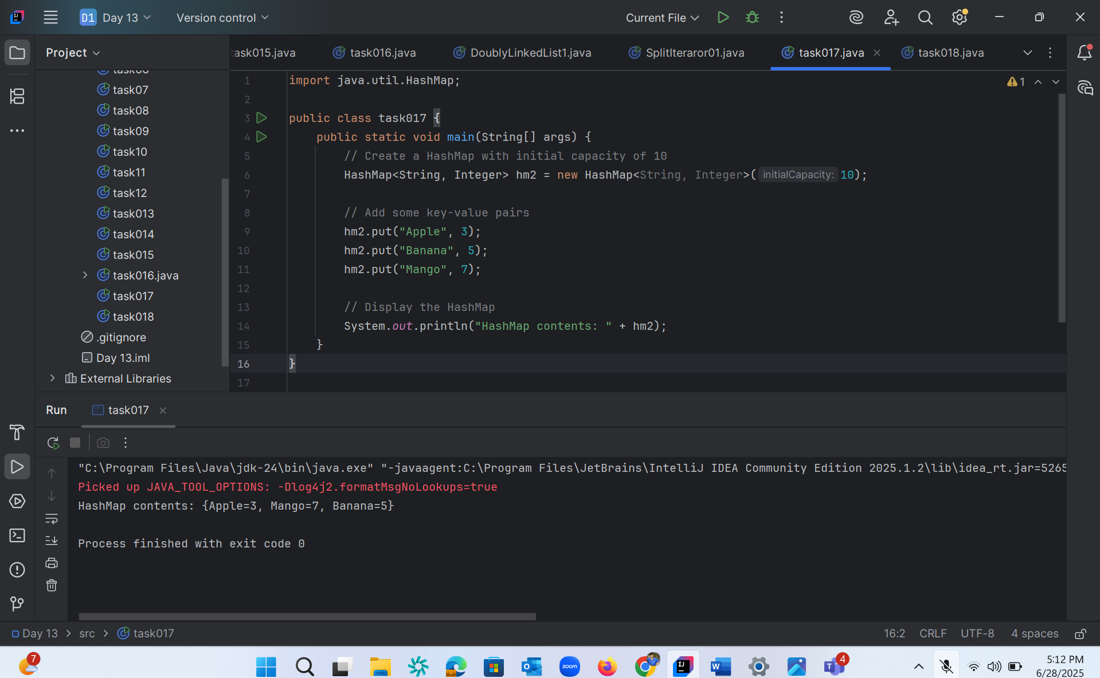

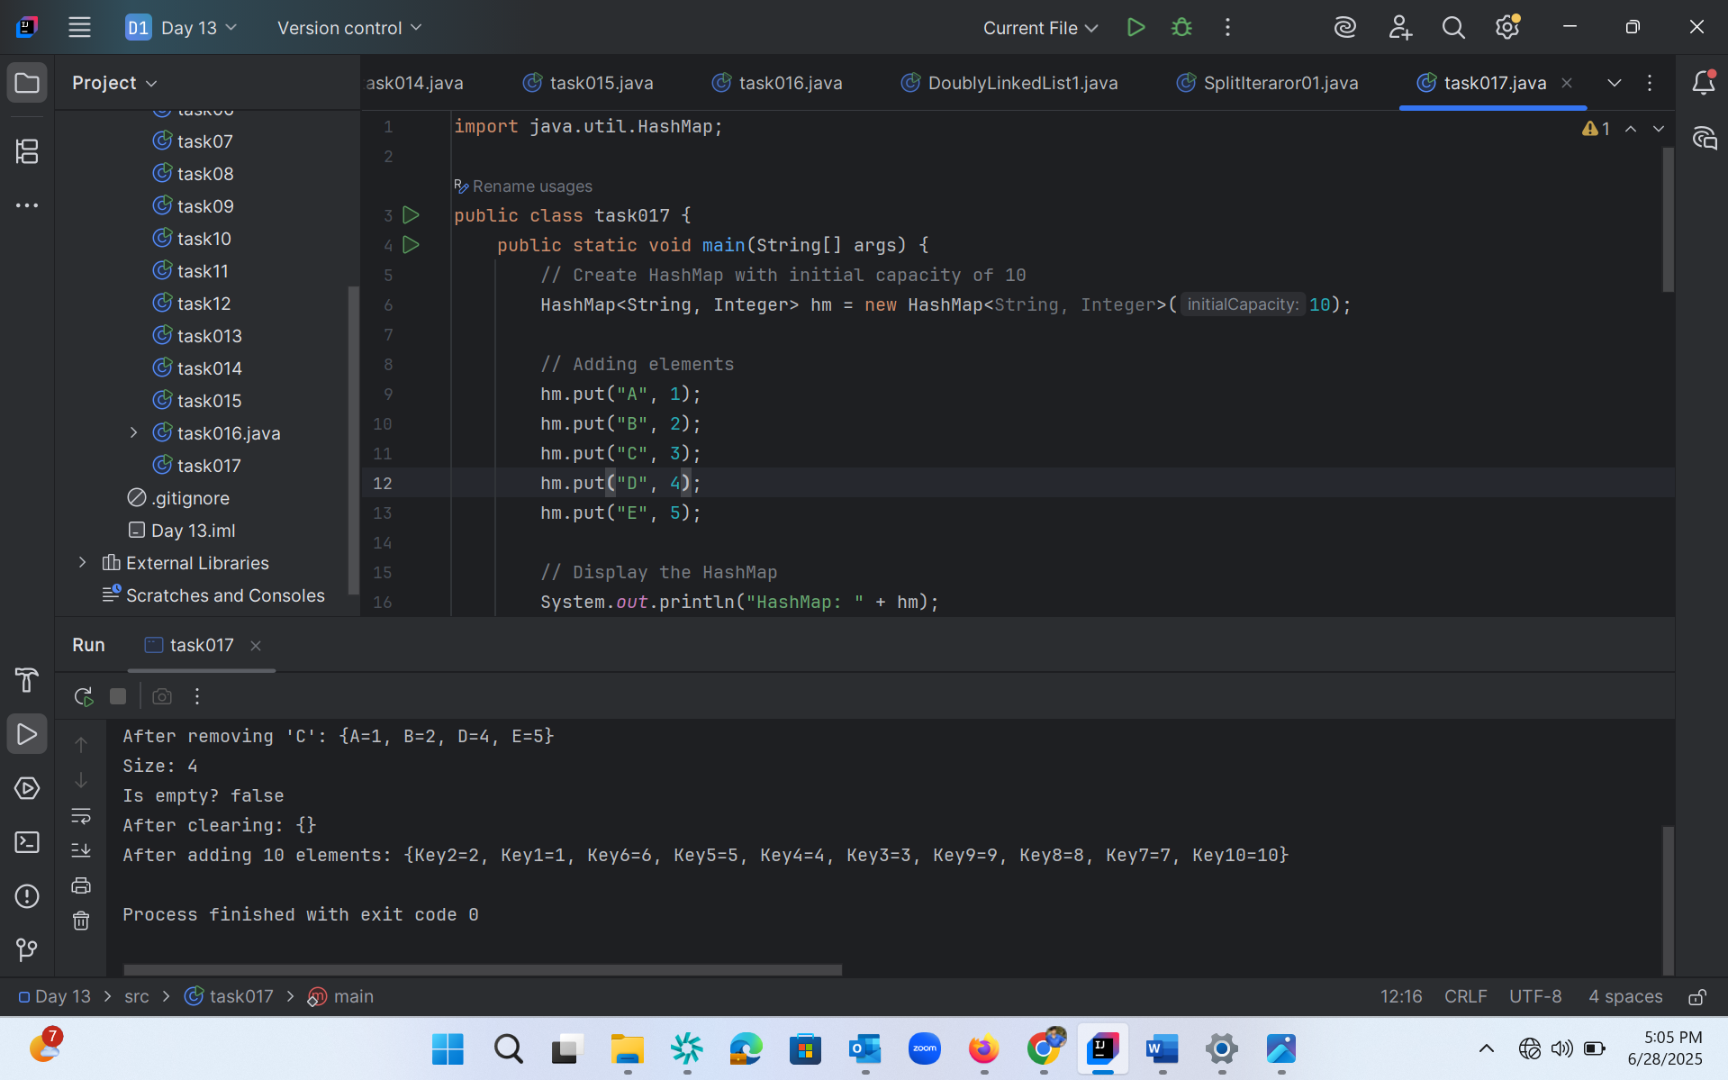

Task 18 :

import java.util.HashMap;  
  
public class task018 {  
 public static void main(String[] args) {  
 // Original map  
 HashMap<String, Integer> hm2 = new HashMap<>();  
 hm2.put("Apple", 10);  
 hm2.put("Banana", 20);  
 hm2.put("Mango", 30);  
  
 // Copy data from hm2 to hm3 using constructor  
 HashMap<String, Integer> hm3 = new HashMap<>(hm2);  
  
 // Display the copied map  
 System.*out*.println("Original Map (hm2): " + hm2);  
 System.*out*.println("Copied Map (hm3): " + hm3);  
 }  
}

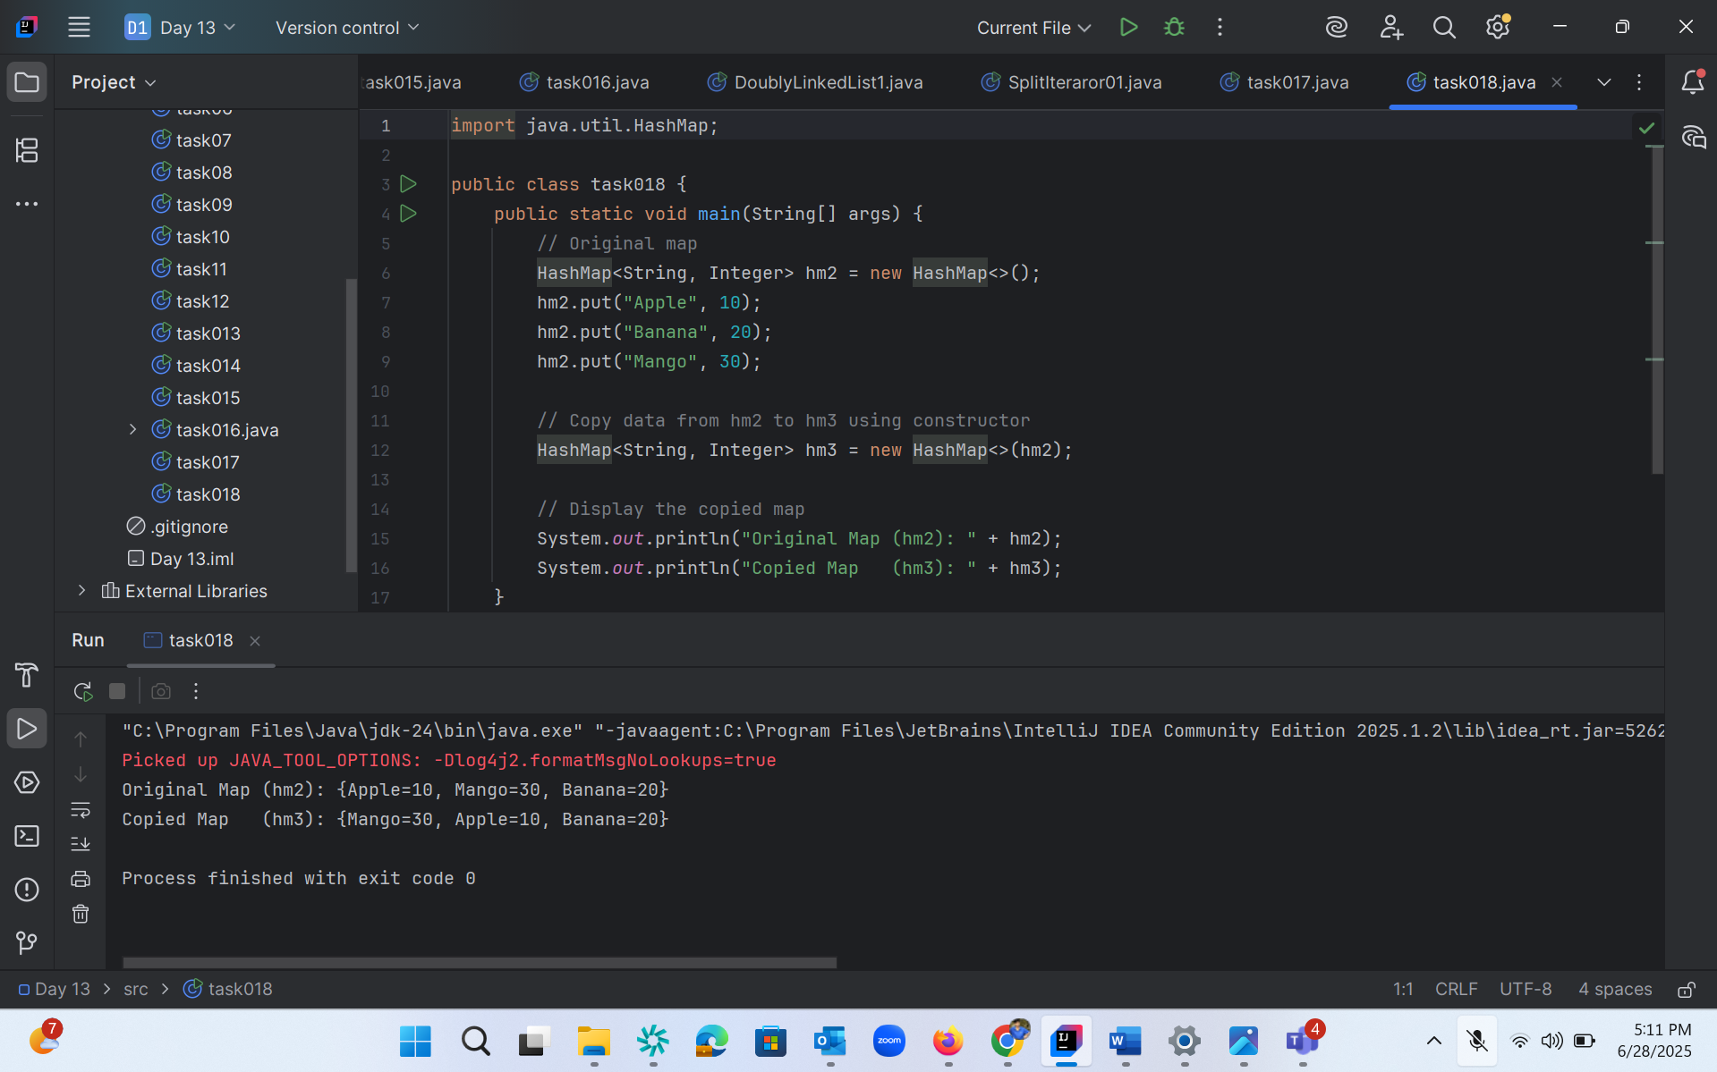

Task 19:

Create a  hash map using a lod factor

Hint:

HashMap<String, Integer> hm4= new HashMap<String, Integer>(10, 0.75f);

Initial capacity  ===10

Load factor  === 0.75f

import java.util.HashMap;  
  
public class task019 {  
 public static void main(String[] args) {  
 // Create HashMap with initial capacity 10 and load factor 0.75  
 HashMap<String, Integer> hm = new HashMap<String, Integer>(10, 0.75f);  
  
 // Calculate threshold  
 int initialCapacity = 10;  
 float loadFactor = 0.75f;  
 int threshold = (int)(initialCapacity * loadFactor);  
  
 System.*out*.println("Initial Configuration:");  
 System.*out*.println("Initial Capacity: " + initialCapacity);  
 System.*out*.println("Load Factor: " + loadFactor);  
 System.*out*.println("Threshold before rehashing: " + threshold);  
  
 // Adding elements to HashMap  
 System.*out*.println("\nAdding elements to HashMap:");  
  
 hm.put("One", 1);  
 System.*out*.println("Added One: " + hm.size() + " elements");  
  
 hm.put("Two", 2);  
 System.*out*.println("Added Two: " + hm.size() + " elements");  
  
 hm.put("Three", 3);  
 System.*out*.println("Added Three: " + hm.size() + " elements");  
  
 hm.put("Four", 4);  
 System.*out*.println("Added Four: " + hm.size() + " elements");  
  
 hm.put("Five", 5);  
 System.*out*.println("Added Five: " + hm.size() + " elements");  
  
 hm.put("Six", 6);  
 System.*out*.println("Added Six: " + hm.size() + " elements");  
  
 hm.put("Seven", 7);  
 System.*out*.println("Added Seven: " + hm.size() + " elements");  
  
 // After threshold (7.5), HashMap will rehash  
 hm.put("Eight", 8);  
 System.*out*.println("Added Eight: " + hm.size() + " elements (Rehashing may occur)");  
  
 // Display final HashMap  
 System.*out*.println("\nFinal HashMap contents:");  
 for(String key : hm.keySet()) {  
 System.*out*.println("Key: " + key + ", Value: " + hm.get(key));  
 }  
  
 // HashMap operations  
 System.*out*.println("\nHashMap Operations:");  
 System.*out*.println("Size of HashMap: " + hm.size());  
 System.*out*.println("Contains key 'Three'? " + hm.containsKey("Three"));  
 System.*out*.println("Value for key 'Four': " + hm.get("Four"));  
 }  
}

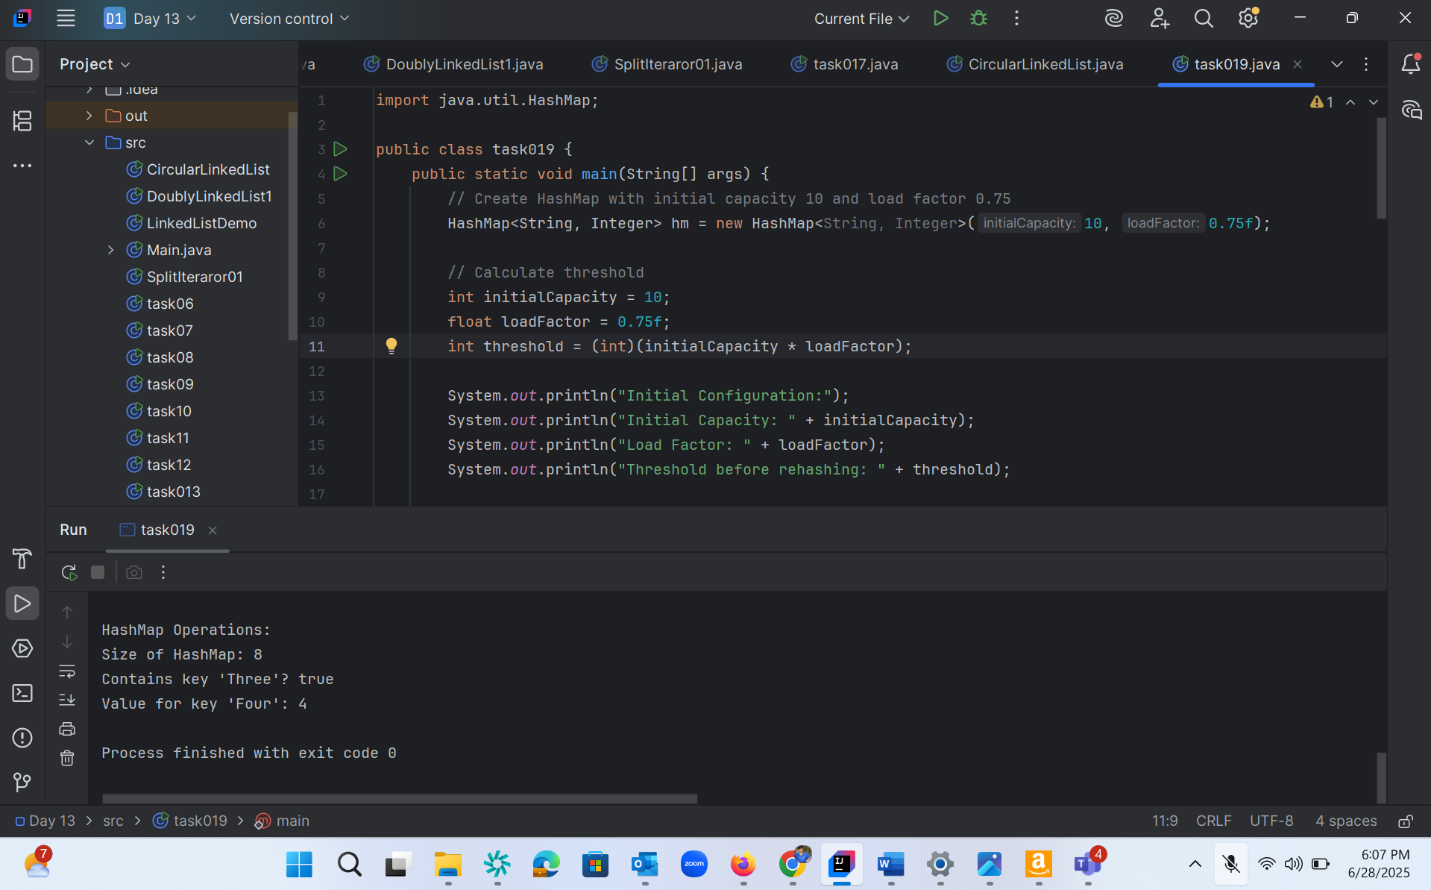

Task 21 :

public class CircularLinkedList {  
 // Node class  
 class Node {  
 int data;  
 Node next;  
  
 public Node(int data) {  
 this.data = data;  
 this.next = null;  
 }  
 }  
  
 private Node head = null;  
 private Node tail = null;  
  
 // Method to add a node to the circular linked list  
 public void addNode(int data) {  
 Node newNode = new Node(data);  
  
 // If list is empty  
 if (head == null) {  
 head = newNode;  
 tail = newNode;  
 newNode.next = head; // Make it circular  
 } else {  
 tail.next = newNode; // Add new node after tail  
 tail = newNode; // Make new node as tail  
 tail.next = head; // Connect tail to head  
 }  
 }  
  
 // Method to display the circular linked list  
 public void display() {  
 if (head == null) {  
 System.*out*.println("Circular Linked List is empty");  
 return;  
 }  
  
 Node current = head;  
 System.*out*.print("Circular Linked List: ");  
 do {  
 System.*out*.print(current.data + " -> ");  
 current = current.next;  
 } while (current != head);  
 System.*out*.println("(back to head)");  
 }  
  
 // Method to count nodes in the circular linked list  
 public int countNodes() {  
 if (head == null) return 0;  
  
 int count = 0;  
 Node current = head;  
 do {  
 count++;  
 current = current.next;  
 } while (current != head);  
  
 return count;  
 }  
  
 public static void main(String[] args) {  
 CircularLinkedList cll = new CircularLinkedList();  
  
 // Adding nodes  
 cll.addNode(1);  
 cll.addNode(2);  
 cll.addNode(3);  
 cll.addNode(4);  
 cll.addNode(5);  
  
 // Display the list  
 cll.display();  
  
 // Display count of nodes  
 System.*out*.println("Number of nodes: " + cll.countNodes());  
  
 // Demonstrate circular nature  
 System.*out*.println("\nDemonstrating circular nature (10 iterations):");  
 Node current = cll.head;  
 for (int i = 0; i < 10; i++) {  
 System.*out*.print(current.data + " ");  
 current = current.next;  
 }  
 }  
}

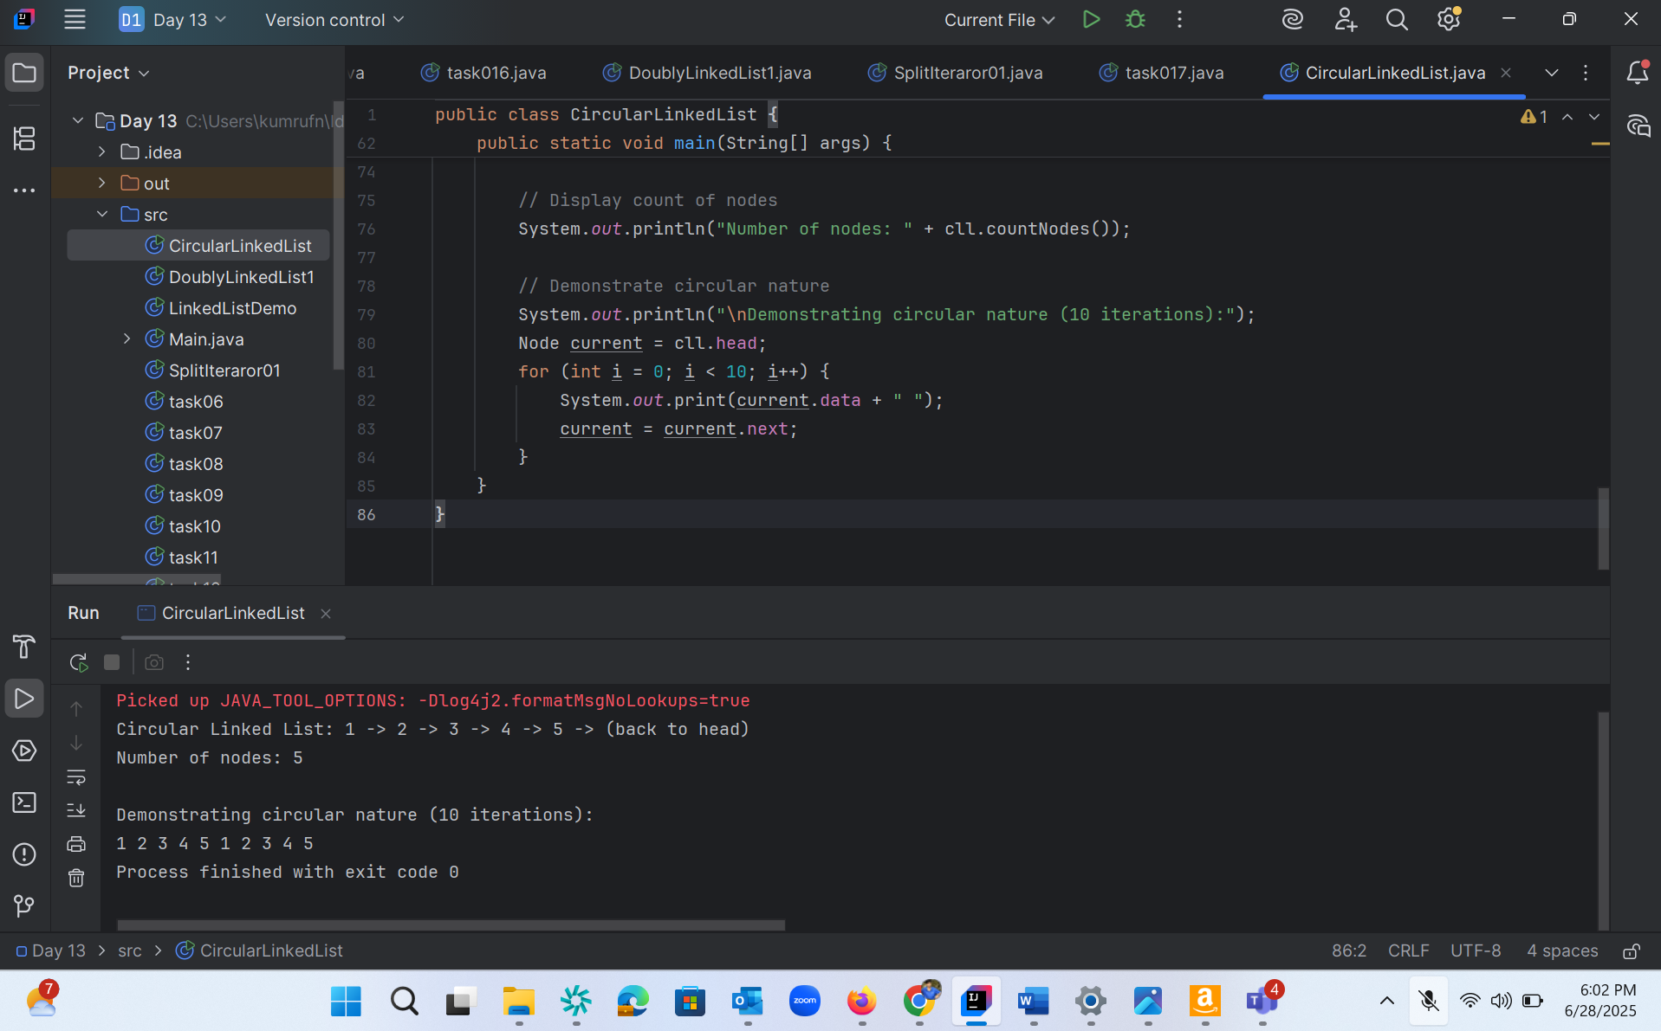

Task020_DS_HashMapCreateMethods:

Different methods to create a hashmap in java :

1) Constructing a hashmap with default capacity

ex:

 HashMap<String, Integer> hm1 = new HashMap<String, Integer>();

2) Constructing a hashmap with a capacity 10

ex:

HashMap<String, Integer> hm2 = new HashMap<String, Integer>(10);

3)copy one map to another map

ex:

HashMap<String, Integer> hm3 = new HashMap<String, Integer>( hm2);

4)

Specifying load factor along with the capacity

ex:

 HashMap<String, Integer> hm4= new HashMap<String, Integer>(10, 0.75f);

Initial capacity  ===10

Load factor  === 0.75f